# *PROJECT REPORT*

# *IREVOLUTION : A DATA - DRIVEN EXPLORATION OF APPLE’S IPHONE IMPACT IN INDIA*

# *ST.JOHN’S COLLEGE,*

**PALAYAMKOTTAI**

TEAM MEMBERS:

1. JEEVA SHINOLA SHARON

A.JELIN

M.JEBA SUDHA

1. JASMINE MARIYA SELVI

# *IREVOLUTION : A DATA - DRIVEN EXPLORATION OF APPLE’S IPHONE IMPACT IN INDIA*

# *INTRODUCTION :*

***PROJECT DESCRIPTION :***

The world has changed as a consequence of the increasing use of smartphones, which have Improved communication, connected people, and revolutionized many different businesses. With its main product, the iPhone capturing markets around the world, Apple Inc. has emerged as a prominent player among the top Smartphone makers. India, one of the economies with the greatest economic growth, has seen a tremendous increase in Smartphone usage, making it an interesting market to study the effects of Apple's phone-in order to shed light on important factors like market penetration, customer preferences, economic ramifications, and societal changes, this research report will perform a data-driven investigation of the impact of the phone in India. This study will offer invaluable insights into the transformative impact of the iphone on India's technological landscape and the lives of its consumers by using advanced data analytics techniques and analyzing large datasets. Apple has a special chance to increase its market share and develop a significant presence in India thanks to the country's large population and rising Smartphone adoption. Each new phone model unveiling generates excitement and anticipation among Indian buyers. By utilizing the plethora of information Already accessible, this research aims to go beyond conjecture and anecdotal evidence in order to develop a thorough knowledge of the effects of the phone.

***OVERVIEW:***

Apple Inc (Apple) designs, manufactures, and markets smartphones, tablets, personal computers, and wearable devices. The company offers software applications and related services, accessories, and third-party digital content. Apple's product portfolio includes phone, iPod, Mac, iPod, Apple Watch, and Apple TV.

***PURPOSE :***

The Iphone is a Smartphone made by Apple that combines a computer, iPod, digital camera and cellular phone into one device with a touch screen interface.

PROBLEM DEFINITION & DESIGN THINKING :

*Empathy Map*

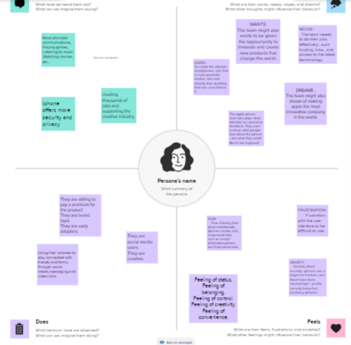

***BRAINSTORMING & IDEATION MAP :***

**BENEFITS OF APPLE IPHONE :**

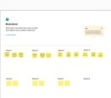

***RESULT :***

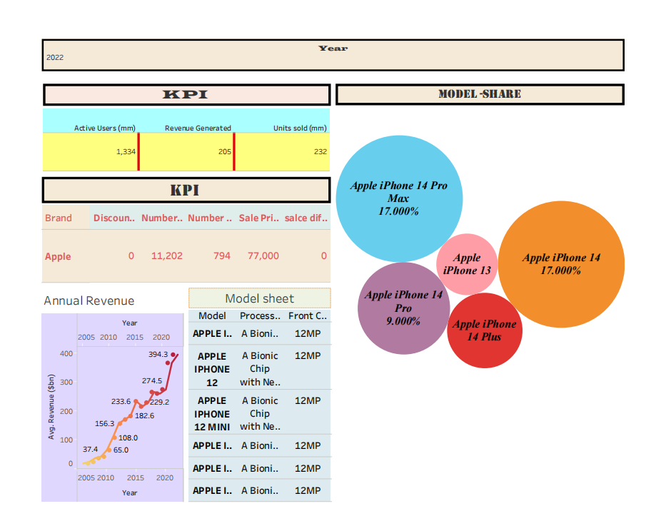

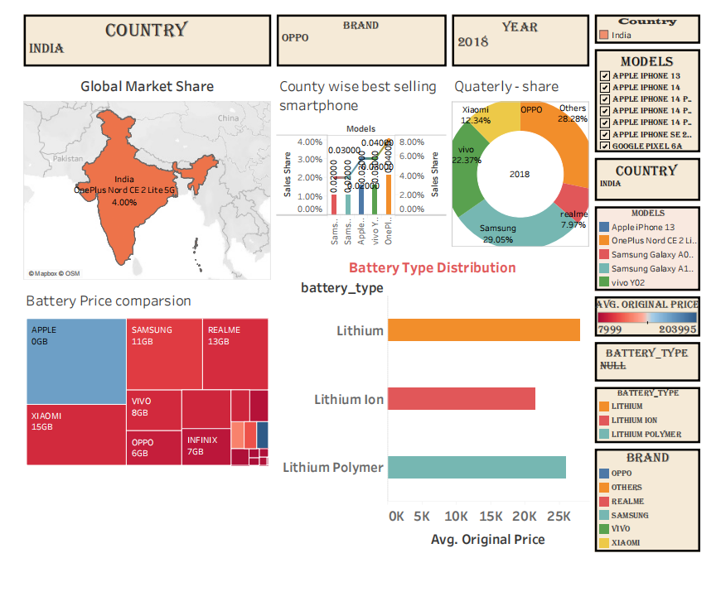

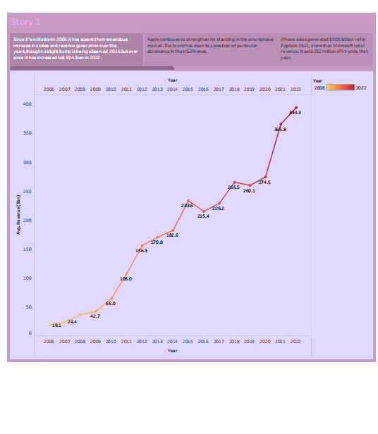

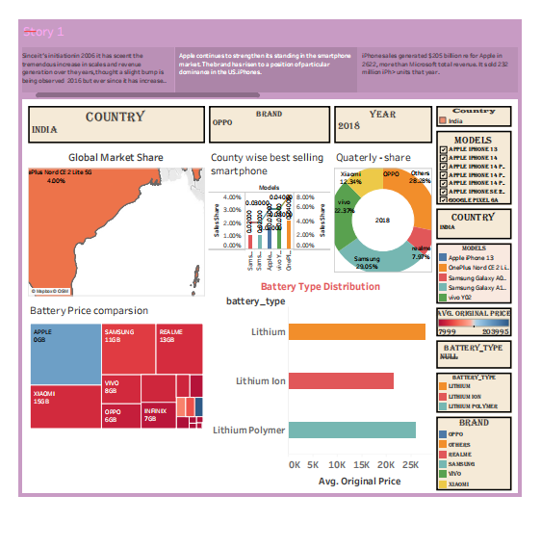

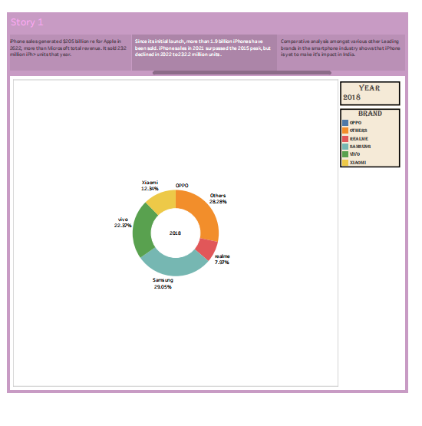

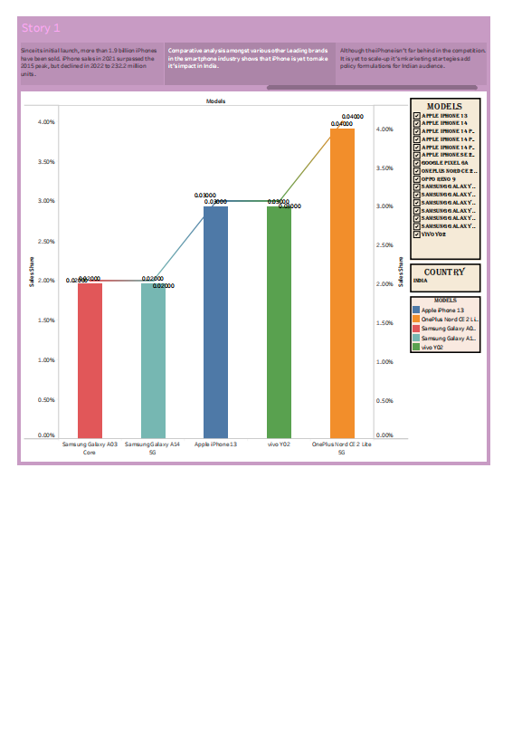

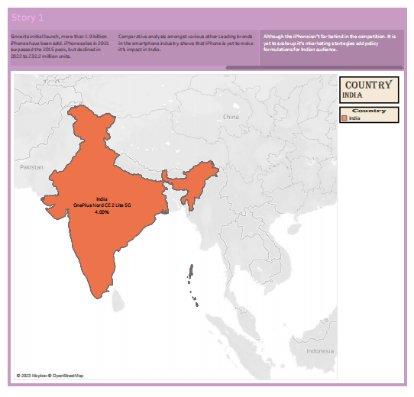

***Advantages :***

* **Design and Build Quality** :Let’s start with the basics: design and build quality. One of the things that immediately sets iPhone apart from Androids is their sleek, streamlined design. iPhone have a distinctive look and feel that’s hard to beat. They’re also incredibly well-built, with durable materials and attention to detail that ensure they’ll last for years to come.
* **User Experience :** One of the biggest advantages of iPhone over Androids is the user experience they provide. Apple has always been known for its intuitive, user-friendly design, and this carries over to their smartphones as well. Everything from the interface to the apps themselves is designed to be as simple and straightforward as possible, making it easy for users to pick up their iPhone and start using it right away
* **App Store :** Another major advantage that iPhone have over Androids is the App Store. With over 2 million apps available, the App Store is the largest app marketplace in the world, and it’s exclusive to iPhone and other iOS devices. This means that iPhone users have access to a wider selection of high-quality apps than Android users do.
* **Integration with Other Apple Devices** : One major advantage of iPhones over android phones is their integration with other Apple products, such as Mac computers, iPadsPrivacy and Security
* **Privacy and security** : Privacy and security are major concerns for many smartphone users, and iPhones have a reputation for being some of the most secure devices on the market. Apple takes privacy seriously, and iPhones are designed with a variety of built-in security features to protect users’ data and personal information, and Apple Watches. With features like Air Drop, Continuity, and Handoff, users can seamlessly switch between their devices and share content between them.

***DISADVANTAGES :***

* **iPhone Are Overpriced** : Apple increases the price of iPhones every year. iPhone is currently one of the most expensive smartphones out there usually due to its constantly updated physical appearance and tweaks made by engineers within the phone. Apple’s focus is on becoming more user-friendly, however, they turned out to be not so cost-friendly.
* **iPhones Have Fixed Storage** : iPhone comes with a storage range of 64 GB, 128 GB, 256 GB, 512 GB, and 1 TB. If more storage is needed, they offer 5 GB of free i Cloud storage where users can store data within the online cloud rather than in their iPhone’s internal storage. It may seem like a decent amount but with the number of apps and better quality photos stored in a phone, those can be used up within a year or less.
* **iPhone Apps Take Up Too Much Space** : The App Store offers a ton of apps that users can easily download into their iPhones. The main disadvantage of iPhones is that the apps take up a huge amount of storage space that is considered unnecessary. Users have found themselves constantly deleting apps to create space for others, which is not idea.
* **iPhone have Short Battery Life** : The iPhone’s battery life can definitely be better, especially for its price point. Although Apple has updated it to be better than before, its battery life is still not up to par with other premium smartphones. The best battery life possible for i Phones would be the newest iPhone 14 sitting at 19 hours and 5 minutes.
* **There Are Several Security Issues With The i phones :** There have been many instances of security issues with the new iPhone 14. There is no SIM card needed, which causes more trouble than they let on. It is much easier for hackers to hack on an e-SIM than an actual SIM card. This is also true with older models when connecting to the Internet in public. Hackers are able to easily steal data from the user’s i Cloud.

***APPLICATIONS :***

* **A software application that runs under iOS, which is the operating system that powers Apple's mobile devices.** In most cases, any application that runs on an iPhone also runs on an iPad and iPod touch.
* **Apple Application Support is a software component developed by Apple Inc.** It is primarily used to ensure compatibility and provide necessary frameworks for various Apple applications to run smoothly on Windows operating systems.

***CONCLUSION :***

Conclusion Apple and the IPhone is a great example of a corporation making what the consumer wants in a global market. With limited companies competing, competition for the best phone on the market is at an all-time high

***FUTURE SCOPE :***

Looking out 10 years, the Apple of 2030 should continue to incrementally improve its hardware products and even introduce some new ones -- but in a new twist, Apple will also expand its brand to develop a suite of bundled consumer services. That will be a big challenge for the tech giant, but also an opportunity.

***SOURCE CODE :***

https://github.com/jeevashinola/apple-iPhone.git